## 《GameJam Artifact！ AIGC Facilitates Rapid Game Development!》01

By: Petybear

Game developers may have heard of various GameJams, independent game development competitions that typically require developers to complete a demo-level game in a very short period of time (the most famous Global Game Jam requires completion within 48 hours). One of the most headache-inducing problems is how to obtain art assets and implement gameplay, which may involve numerical systems. The goal of this article series is to demonstrate how AIGC can assist independent game developers in achieving their game development goals quickly, using a 2D pixel game as an example. This article is the first in the series, focusing on the topic of AI-assisted creation of pixelated scenes.

IMG_256

Objective: Use AI to assist in creating 2D isometric pixel games.

Before reading

make sure you have subscribed to and are familiar with the following tools:

 

Target audience for this tutorial: Independent game developers.

Step 1: Determine the game perspective and style  
Game type: 2D isometric pixel game.

Canvas size: The dimensions of the scene assets are 256×256 pixels, and the dimensions of the character assets are 32×32 pixels, with a resolution of 300PPI. The larger the size, the more details can be accommodated, as shown in Figure 1. Figure 2 shows a visual representation of our 2D game creation in the engine.

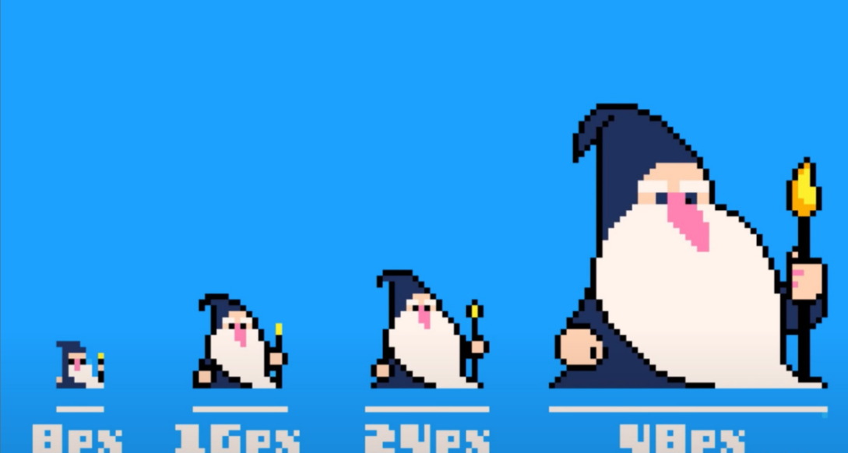

IMG_256

Therefore, we need to obtain 2D pixelated, isometric flat scene assets and process them into the required pixel dimensions.

### Step 2: Draw the background assets

To create this type of 2D game with an isometric perspective, the background and buildings are usually separated into different layers. Therefore, we need to first draw the bottom layer of the map: the background layer.

First, we need to determine the goal: a square image with elements of grass and dirt road.

We tried generating the background assets in Midjourney, and after repeated iterations and selection, we obtained the desired background assets.：**pixel art, 2D, top view, grass and mud road, consecutive, no people, background**

**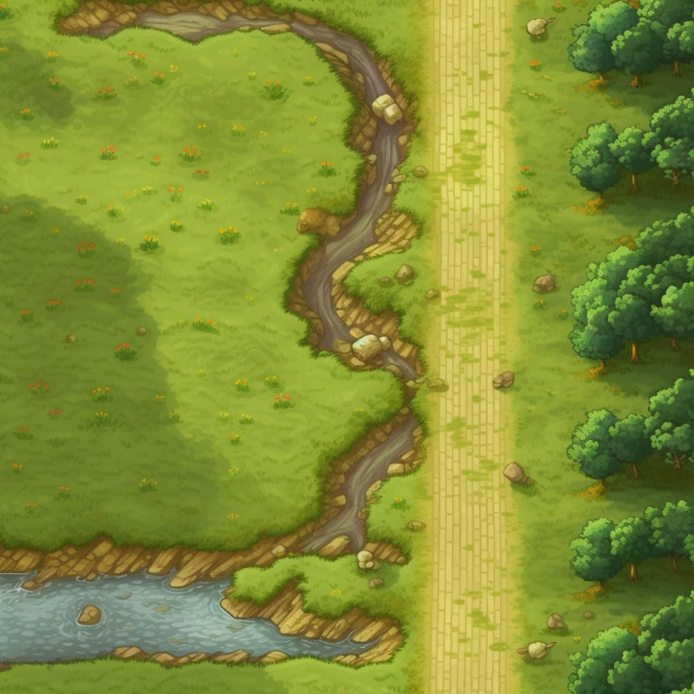**

Note: Since we are generating assets for the game background, we must include the keyword "consecutive" in the generation process. Otherwise, the result may look like the following image:**pixel art, 2D, top view, grass and mud road, background, no poeple**

IMG_256

### Step 3: Creating Building Assets

First, let's observe similar games on the market. A popular approach is to use a building perspective with a front view and a 45-degree angle.

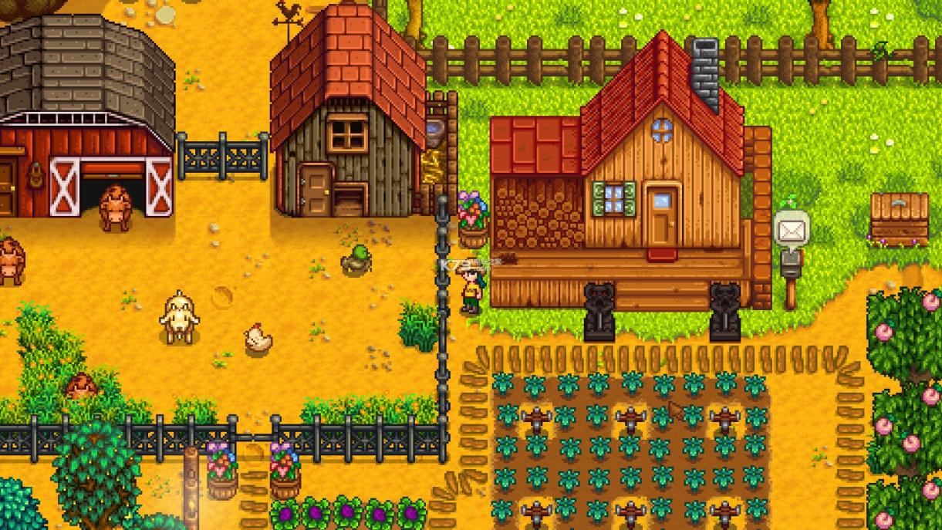

This is a screenshot from the game "Stardew Valley," just for display purposes.

We want to draw a small wooden house that is warm and full of life.

So we tried drawing it in Midjourney:**Looking down from the front, Pixel art, a wooden house, forty-five degree angle**

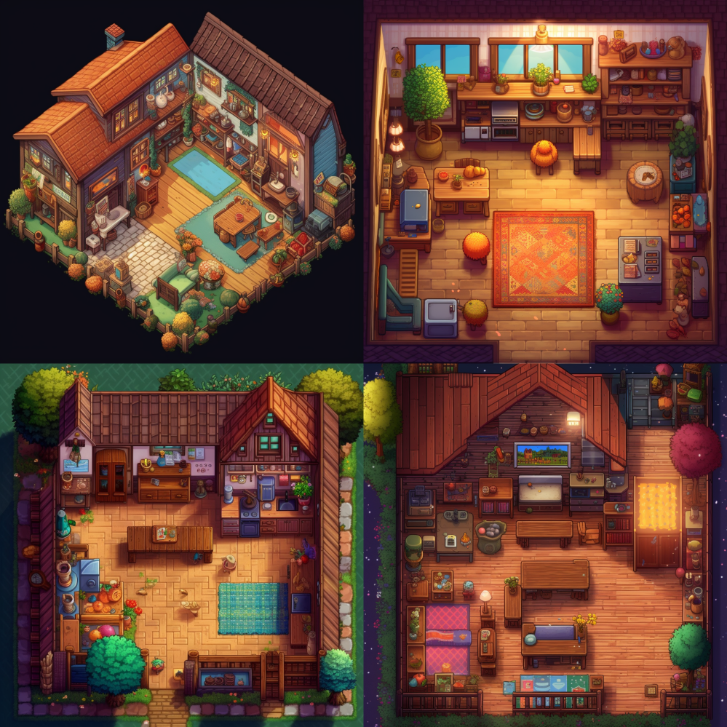

But we found that the generated image from the prompt also includes the interior and other props, which is not what we want. We want a clean, outdoor top-down view of the wooden house.

So I tried some different tags and found the following two that can quickly improve the performance of Midjourney:Looking down from the front + outdoor

Keep going：**Looking down from the front, outdoor, Pixel art, a wooden house**

**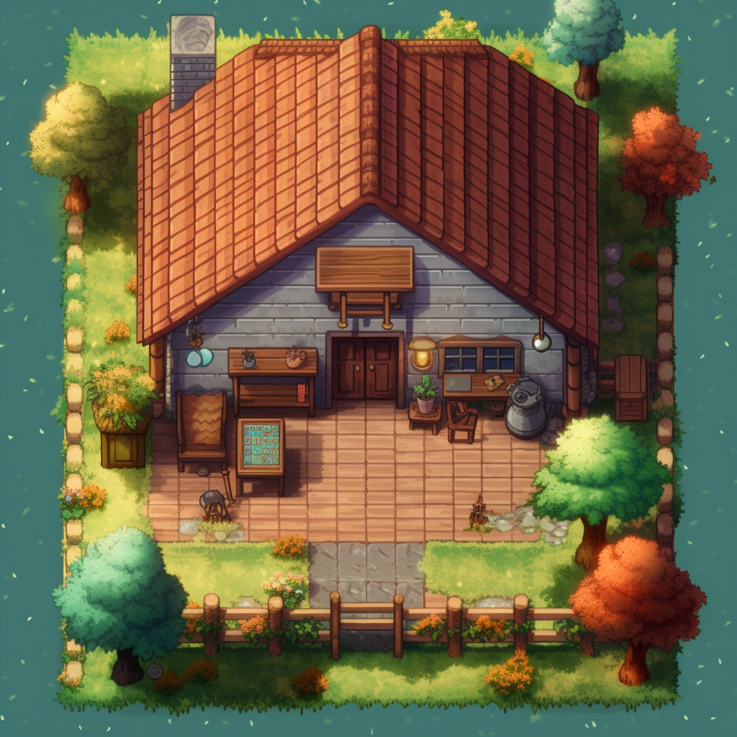**

This result is more in line with our requirements. The next step is to process the materials according to our specifications.

### Step 4: Standardizing the Material

As of now, we have obtained two images, but these can only be called pixel-style images, not pixel art assets. This is because we have not processed them to meet game specifications. Below, I will explain how to do this step.

01: Open Photoshop, create a new canvas with dimensions of 256×256 pixels and 300 PPI.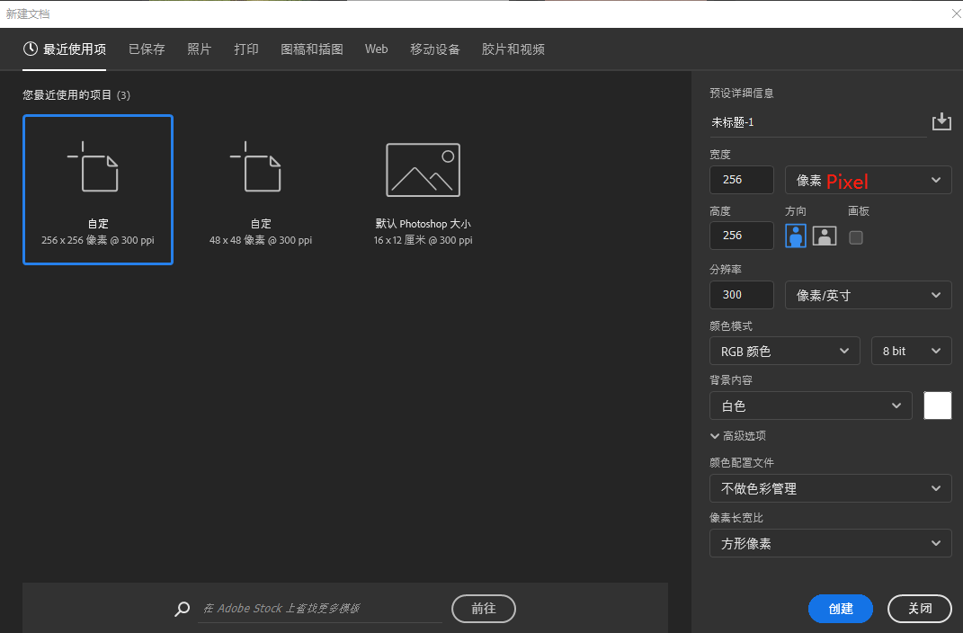

02: Go to Edit -> Preferences -> General, and change Image Interpolation to "Nearest Neighbor (Preserve Hard Edges).

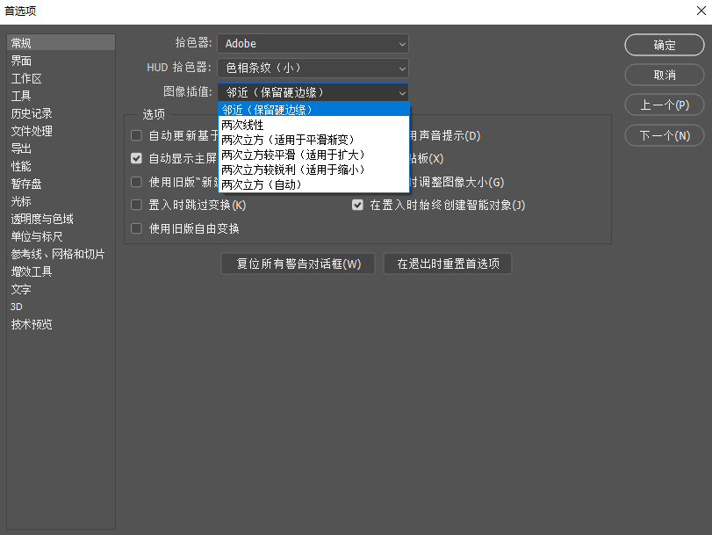

Image > Image Size > Resample, check Nearest Neighbor (preserve hard edges).

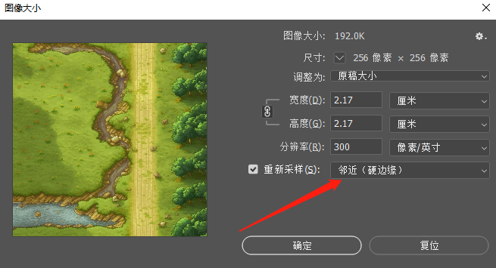

Change the unit of the ruler to pixels and the type of measurement to points in the Preferences > Units & Rulers panel to facilitate size standardization.

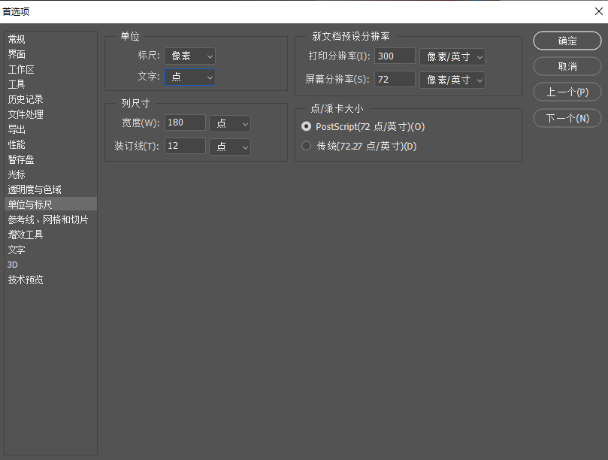

Difference illustration: In non-nearest neighbor interpolation state, enlarging pixel resources will cause blurring, which will cause serious problems after entering the game engine.

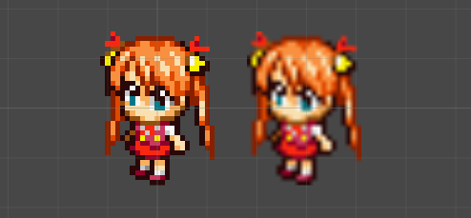

03. Cut out and process the house material.

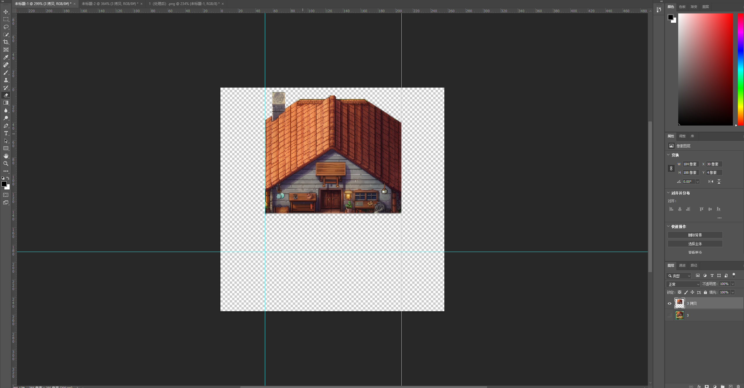

At this point, we have obtained two desired assets, and we can have a preliminary preview to check if the effect is satisfactory. The uploaded images here have been processed to 256×256 Pixel, so the image quality may be slightly reduced.

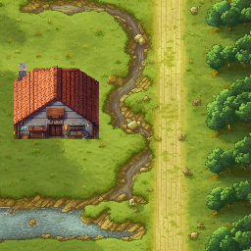

### Next article preview:

The next article in this series will bring you a guide on how to generate more pixel-style buildings and props using AI.

